Teaching Strategies for Chapter XIII

Interfaces and Abstract Classes

Since the start of Java, Interfaces and Abstract Classes seems to cause more confusion than any other topic, unless we throw in Polymorphism, which is closely connected with interfaces.

I used to teach a unit on Polymorphism and in this unit interfaces, abstract classes and polymorphism were happily and merrily thrown together. I have now decided - since the 2014 Exposure Java edition - to separate the topics.

This chapter will totally focus on interfaces, abstract classes and also how generics works with interfaces and classes. Polymorphism will not be included. There is plenty to go around to make sure that the fundamentals of an interface, implementing an interface and abstract classes are understood.

Part of the problem with the one chapter-polymorphism approach is that a simplistic view of interfaces is acquired. Ah, we need interfaces to accommodate polymorphism. This view is problematic several ways. First, polymorphism can be achieved without interfaces and second, interfaces have a strong reason to exist, even if polymorphism did not exist. In other words, I am now continuing, but polymorphism will need to wait for the next chapter.

Perhaps you had expected a chapter on Two-Dimensional Arrays next. That certainly was the sequence of previous years. When I started the 2D chapter I pondered about the integration of the new AP Picture Lab. This lab has its primary focus on 2D arrays, but the program examples also use interfaces and implementing concrete classes. I have never felt satisfied with any previous interfaces, abstract classes and concrete classes unit I have written. I feel much better about this totally redone unit.

This time I created the separate chapter since I did not again wanted to shove it in as a weak appendix to another chapter, like 2D Arrays. From here we can continue to Polymorphism and then go to 2D arrays and look at the AP Lab focusing on 2D Array processing with interface and abstract stuff behind us with this chapter.

I mention frequently at workshops that I use the question what does it mean in English frequently or I say what does it mean in computer science? Computer science terms are not just created from scratch. Technical language has its foundation in the language used by the culture. In other words with this chapter I start by asking:

What is abstract in English?

Adding, in English, is important. My better computer science students jump straight into the meaning that applies to computer science and programming. I have learned that if students see the English connection, the concepts is better understood and easier remembered.

Abstract is an excellent starting point for this chapter. An interface is abstract. An abstract class is part abstract part concrete. A concrete class is totally concrete. So none of this business makes sense unless abstract and concrete are understood.

My personally favorite definition for abstract is as follows:

abstract cannot be detected by any human senses.

Concrete then continues and can be detected by human senses.

From there I may mention that abstractness is talking about ideas without concern how to implement such ideas.

This is a good switch to computer science. In the real world there are business people with limited computer science knowledge who get together with software engineers with limited business knowledge. How do they communicate?

Well they interface, but at the idea level, at the abstract level. The business people explain what they need. A Bank administrator can explain all the procedures that new bank software needs to perform. Each needed procedure becomes a method. It can have a name and also information about parameters. Implementing such methods comes later at the software engineer’s office.

The chapter gives the example how President Kennedy announced that he wanted to land a man on the moon. On that same day people could sit down and say what is required. They can say we need Astronaut Selection & Training, but not yet know what the selection process is and what training is necessary. They know that a rocket is needed, fuel is needed, communication, oxygen, etc. All the requirements can be discussed without yet knowing the details.

You start by showing an interface. You can demonstrate that the interface compiles. It won’t execute. It has neither a main method nor is it an applet. You can try to instantiate the interface. In other words, not as a graded lab, but as a lab exercise have your students play around with the interface.

Now start to create some concrete classes. See what happens if the concrete classes do not implement all of the abstract methods. See what happens if you implement more. Declare some data attributes and observe what they can and cannot do.

After the abstract interface and the concrete classes are clear move on to the abstract class. In this chapter there will be two examples given. More follows in the later Polymorphism chapter.

The chapter has a pretty good size HighSchool interface. It has 12 abstract methods. 4 concrete classes need to be made with 12 concrete methods each. That is implementing 48 methods.

A short examination of the HighSchool methods makes you realize that some methods are identical for every grade, such as provide personal information while others are very different, such as student parking.

What comes to the rescue here is the abstract class. An abstract class can have abstract methods and concrete methods. This is perfect for our situation. We find all the abstract methods that every grade has in common. There are 7 such methods. The textbook chapter shows a diagram that is repeated on the next page. The 7 common methods are in lavender and the different methods are turquoise.

The abstract class now has the job to implement the common methods. Once that is done, you can then continue and create 4 concrete classes for 4 grade-levels. Each grade-level class extends – not implements – the abstract class and then only 5 methods needs to be written for each class.

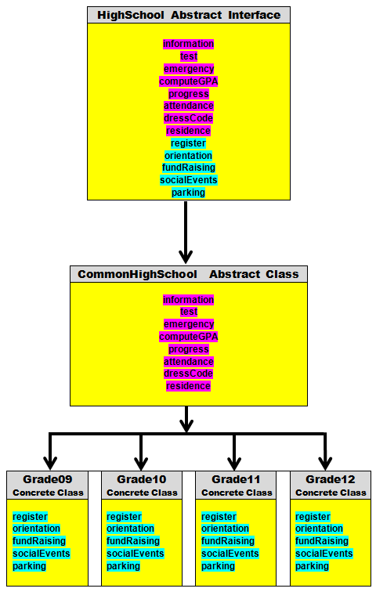

This chapter also shows another purpose for an abstract class. It can be used as an adapter class. It can happen that a program needs to use an interface. Perhaps the interface has 12 abstract methods. 12 is nice, but right now your program only needs to use one of the methods.

Now by the rule that states that every abstract method must be implemented in a concrete class, you must implement 12 methods. 1 method will have actual meaning and 11 methods are dummy methods. This is shown by figure 13.36.

Figure 13.36
// AbstractClass05
// This is the <Grade09> implementation of the <HighSchool> interface.
// None of the other methods have to be implemented anymore.
public class Grade09A implements HighSchool
{
public void information()
{
System.out.println("Process 9TH GRADE information");
}
public void test() { }
public void emergency() { }
public void computeGPA() { }
public void progress() { }
public void attendance() { }
public void dressCode() { }
public void residence() { }
public void register() { }
public void orientation() { }
public void fundRaising() { }
public void socialEvents() { }
public void parking() { }
}

There is a solution. Using an abstract class, usually called an adapter, you can implement every abstract method as an empty “dummy” method. After this is done any concrete class can now extend the HighSchoolAdapter class and implement only as many methods as are needed.

Some of your alert student may argue that the adapter class functionality can be achieved with a regular class just as easily. Very true. However the point of the adapter class is not to create a concrete class that can be instantiated. Using an abstract class prevents that capability and puts focus on its intended purpose to make the use on an interface simpler.

This chapter requires using analogies connecting abstractness and concreteness to real life. You also need lab exercises to observe what works properly.

Make sure that students understand that the interface and abstract story is not finished. More will be added in the polymorphism chapter.

The earlier ArrayList chapter introduced generic data structures. Students learned how to declare a generic, dynamic array with a statement, like:

ArrayList<String> names = new ArrayList<String>();

When you look at the quick reference guide provided by the College Board you can see the List interface below with its generic <E> syntax. This can be quite confusing to students, especially when taught the last second before the exam. This chapter covers the <E> in detail.

